Nama : Ananda Mohammad B

NIM : 18090132

Kelas : 5A

**PRAKTIKUM 1**

1. Source Code

Kenalin.php -> application/controller

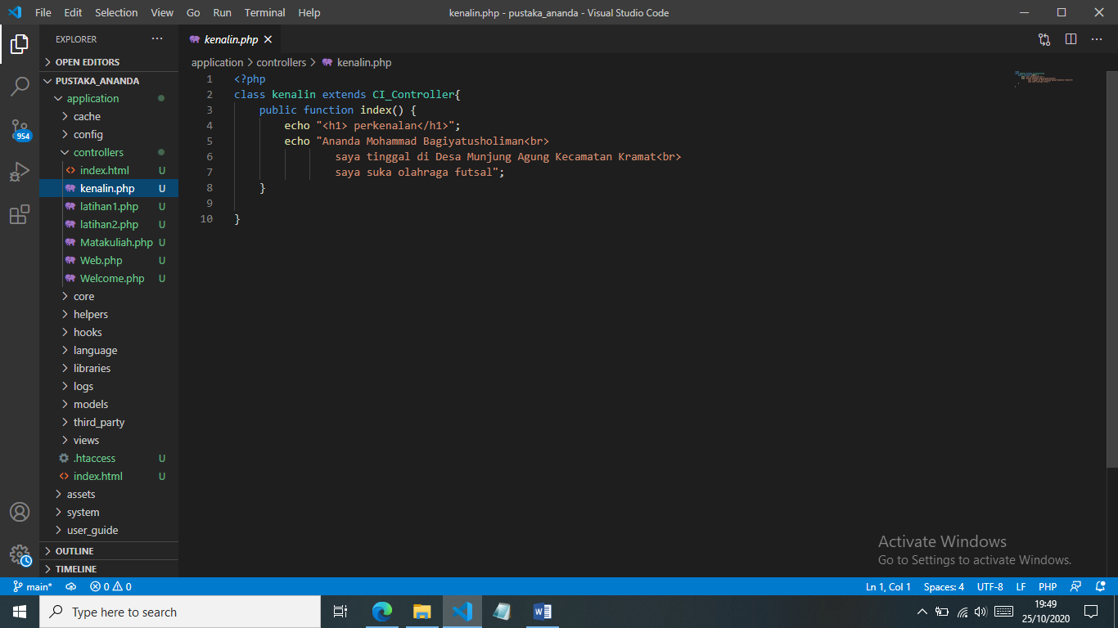

1. URL

<http://localhost/pustaka_ananda/index.php/kenalin>

1. Capture Hasil

